Tanja Poppelreuter
Expressionism
‘Expressionism’ describes an early twentieth-century avant-garde movement that originated in Germany. 1905 is usually agreed upon as its year of origin, as it was the founding year of the artist group Die Brücke (The Bridge). Around 1920, its expressive idiom was slowly replaced with the more rational one of the Neue Sachlichkeit (New Objectivity) movement. Expressionism found its representatives mainly in painting, sculpture, film, literature, and architecture but also in dance, music and theatre.
Expressionism’s theoretical underpinnings are in the work of Friedrich Nietzsche (1844-1900) and in the 1908 book Abstraktion und Einfühlung [Abstraction and Empathy] by German art historian Wilhelm Worringer (1881-1965). Emotions and tensions were depicted with the help of symbolic colour and lines in the belief that both carry their own innate expressive meaning and have psychological and spiritual effects – a strand of thinking pursued by Wassily Kandinsky (1866-1944) in his 1911 book Concerning the Spiritual in Art (Kandinsky, 1911, Worringer, 1908 and Gordon, 1987).
Painting
Expressionist painting by members of groups such as Die Brücke and Der blaue Reiter (the Blue Rider) related to late nineteenth-century movements such as Symbolism, Post-Impressionism, and Fauvism. Instead of finding inspiration in the truthful reproduction of nature, Expressionism was an attempt to visualise spiritual and psychological aspects of human existence. This is conveyed through subject matter, colour, and distortion of form and line. Inspiration was found in ‘primitive’ art from Pacific and African cultures, in the art of the mentally ill (outsider art or art brut), or in folk art (Lloyd, 1991).
Expressionist Case Study: Architecture
Expressionist architecture is characterised by its use of expressive colour and both organic and crystalline shapes and lines. It is also marked by an interest in monumental and unbuildable structures. Experssionist architecture’s zenith came during and immediately after the First World War, although some of the earlier works of architects such as Hans Poelzig (1869-1936) and Bruno Taut (1880-1938) are regarded as precursors (Sharp, 1966). In the years around 1910, Poelzig took inspiration from Gothic, Romanesque, and Baroque styles for his design of industrial and public buildings. The 1911 Water Tower in Poznan drew its expressiveness from technology.
File: expressionism1.jpg
The Water Tower’s construction of steel with brick and glass fillings, and its solid shape, anchoring it on the ground, created a monumental effect that celebrated industrial achievement and technology. Poelzig’s principles of restrained, sculptural shapes and a surface design where windows merge with walls were also adhered to in his 1906 Werder mill in Breslau and the chemical works in Luban, 1911-12, but his best-known Expressionist building was the Großes Schauspielhaus in Berlin with a dramatic interior that was likened to a magic cave (Pehnt, 1979, 69-78).

File: expressionism2.jpg
File: expressionism3.jpg
Taut had also been an early protagonist of expressionist architecture, most notably with his 1914 Glass Pavilion – a temporary structure for the glass industry built at the Deutsche Werkbund exhibition in Cologne. Through his publications and architectural drawings such as in Der Weltbaumeister [The World Architect; 1920], Die Stadtkrone (1919), and Frühlicht (1920-1922), as well as in his role as city architect of Madgeburg, Taut became a lynch-pin for this movement (Washton Long, 1993, 122-139). Since the 1914 pavilion Taut had taken inspiration from the poet Paul Scheerbart (1863-1915), whose rhymes and poems evoked visions of colourful castles, domes, buildings on mountaintops, and an architecture made of glass, as illustrated by Taut in Alpine Architecture (1919). These ideas fuelled a German utopian spirit that had been gaining momentum since the First World War, the abdication of Wilhelm II, and the establishment of the Weimar Republic. Architects saw themselves as demiurges of a new society and future.

File: expressionism4.jpg
File: expressionism5.jpg
File: expressionism6.jpg

Scheerbart’s Glasarchitektur in particular fuelled the belief of Taut, the architectural critic Adolf Behne (1885-1948), and (in 1919) the members of Die gläserne Kette (The Glass Chain), that the advent of a new ‘glass culture’ would refine morality. Die gläserne Kette was an exchange of utopian letters and drawings initiated and organised by Taut. Disguised by pseudonyms, twelve artists and architects exchanged thoughts, visions, and drawings in a search of the roots of creativity, the origins of architecture, and the relationship between architecture and the cosmos. Among them were Hermann Finsterlin as ‘Prometh’, Walter Gropius as ‘Maß’, Wassili Luckhardt as ’Zacken’, and Hans Scharoun as ‘Hannes’ (Whyte, 1985).

File: expressionism7.jpg
File: expressionism8.jpg

Social Aspects
Social and educational reform and rejection of the city were essential parts of Taut’s ideology and became apparent in his illustrated book Die Auflösung der Städte [The Dissolution of Cities; 1920] and Die Stadtkrone [The Crown of the City; 1919], which also drew on Garden City and socialist ideals. Social reform was also in the centre of the program of the Arbeitsrat für Kunst (Working Council for Art) and Novembergruppe, both of which were organisations of Berlin artists with similar goals. They were among numerous revolutionary organisations initiated by workers and artists all over Germany to watch over the provisional government of November 1918. As early as Christmas 1918, the Arbeitsrat, whose spokesman was first Taut and then Walter Gropius (1883-1969), published an architectural program and a manifesto that declared it to be the task of the artist to give the new state its appearance and to shape people’s experiences. Here, ideas of combining art and architecture to create a Gesamtkunstwerk (total work of art), relating back to the 1914 Werkbund exhibition in Cologne, resurfaced in both publications. The majority of efforts by the Arbeitsrat related to architecture, demanding the abolition and replacement of established institutions such as building authorities, insisting upon an art for the people, and advocating the transformation of existing teaching systems (Washton Long, 1993, 1991-209, 210-221 and Pehnt, 1979).
The idea of a Gesamtkunstwerk and the reformation of teaching institutions were also an essential part of the Bauhaus in Weimar in the years between 1919 and 1923. The Bauhaus programme aimed to unify art and architecture and therefore echoes the writings of the Arbeitsrat and Taut. Lyonel Feininger’s (1871-1956) 1919 woodcut in the manifesto as well as the Sommerfeld Haus [Figs. 9-11] evoked the crystalline shapes that were symbolic for expressionism.

Among the most notable built examples of the movement are Erich Mendelsohn’s (1887-1953) Einstein Tower [see panorama] built 1920-1924 in Potsdam, and Peter Behrens’ (1868-1940) Hoechst Administration building built within the same time-span in Frankfurt am Main [Fig. 12]. Mendelsohn’s streamlined and sculptural design, that make the modestly-sized building appear monumental, is an example of organically shaped expressionism that was also pursued by Hermann Finsterlin in his drawings for the ‘glass chain’. Behrens, who had a successful office in Berlin and was artistic adviser to the Allgemeine Elektrizitäts-Gesellschaft (AEG) since 1907, adapted the dramatic use of colour, shape and space of expressionism in his post-war work. In contrast to the formal and classical work before the war, this building did not adhere to the same strong rules of symmetry, and serial arrangement as previously but incorporated romantic and dramatic elements.
The expressionist movement petered out during the mid and late 1920s. Related movements can be found in the school of Amsterdam and Rudolf Steiner’s Goetheanum in Dornach, Switzerland, among others.

Word Count: 1,185

References and further readings
Benson, T. O. et al. (1994) Expressionist Utopias: Paradise, Metropolis, Architectural Fantasy, Los Angeles: University of California Press.
Gordon, D. E. (1987) Expressionism. Art and Idea, New Haven and London: Yale University Press.
Herbert, B. (1983) German Expressionism: Die Brücke and Der Blaue Reiter, London: Jupiter Books.
Kandinsky, W. (1911) Über das Geistige in der Kunst [Concerning the Spiritual in Art] Piper: München. Translated as The Art of Spiritual Harmony by Michael T. H. Sadler (Dover: New York, 1977. Reprint of the first English translation, 1914).
Available as e-book at: http://web.mnstate.edu/gracyk/courses/phil%20of%20art/kandinskytext.htm
Lloyd, J. (1991) German Expressionism: Primitivism and Modernity, New Haven and London: Yale University Press.
Pehnt, W. (1979) Expressionist Architecture, London: Thames and Hudson.
Pehnt, W. (1985) Expressionist Architecture in Drawings, Van Nostrand Reinhold: New York, Melbourne and Agincourt.
Prange, R. (1991) Das Kristalline als Kunstsymbol – Bruno Taut und Paul Klee. Zur Reflexion des Abstrakten in Kunst und Kunsttheorie der Moderne, Hildesheim: Olms.
Sharp, D. (1966) Modern Architecture and Expressionism, London and New York: Longmans.
Washton Long, R.-C. (1993) German Expressionism. Documents from the End of the Wilhelmine Empire to the Rise of National Socialism, New York, Ontario: Maxwell Macmillan.
Whyte, I. B. ed. (1985) Crystal Chain Letters: Architectural Fantasies by Bruno Taut and His Circle, Cambridge, Mass: The MIT Press.
Worringer, W. (1908) Abstraktion und Einfühlung. Ein Beitrag zur Stilpsychologie. Munich. Translated as Abstraction and Empathy: A contribution to the Psychology of Style by Michael Bullock (New York, 1953, 4th ed., New York, 1980)

Panoramas:
Erich Mendelsohn, Einstein Tower:
http://www.360cities.net/image/potsdam-einsteintower#52.10,-14.50,90.0
Fritz Höger, Chilehaus, Hamburg, 1923-24
http://www.360cities.net/image/hh-chilehouse#1.00,-90.00,70.0

Paratextual Material
Der Golem, wie er in die Welt kam [The Golem: How He Came Into the World], 1920, motion picture, distributed by Universum Film (UFA), Germany.
Art Directors: Hans Poelzig and Kurt Richter.
Movie available at: http://www.youtube.com/watch?v=uZO_Kd3kkwE (1:41:24)
Das Cabinet des Dr. Caligari [The Cabinet of Dr. Caligari] , 1920, motion picture, produced by Decla-Bioscop AG, Germany.
Art Directors: Walter Walter Reimann, Walter Röhrig, Hermann Warm
Movie available at: http://www.youtube.com/watch?v=ecowq77Y3C0

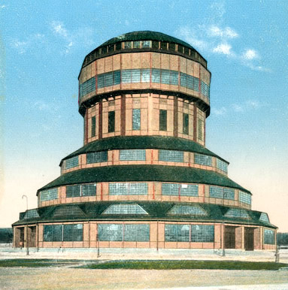
Fig. 1: Hans Poelzig, Water Tower, Poznań, 1911
http://www.historiasztuki.com.pl/ilustracje/Poelzig-Wasserturm.jpg

Fig. 2: Hans Poelzig, Chemical Factory, Luban, 1909-11
Further images and copyright at: Technische Universität Berlin Architekturmuseum in der Universitätsbibliothek http://architekturmuseum.ub.tu-berlin.de

Fig. 3: Hans Poelzig, Großes Schauspielhaus, Berlin, 1919
Further images and copyright at: Technische Universität Berlin Architekturmuseum in der Universitätsbibliothek http://architekturmuseum.ub.tu-berlin.de/index.php?set=1&p=61&D1=Poelzig&D2=Hans&D3=Gro%DFes+Schauspielhaus%2C+Berlin (in German)

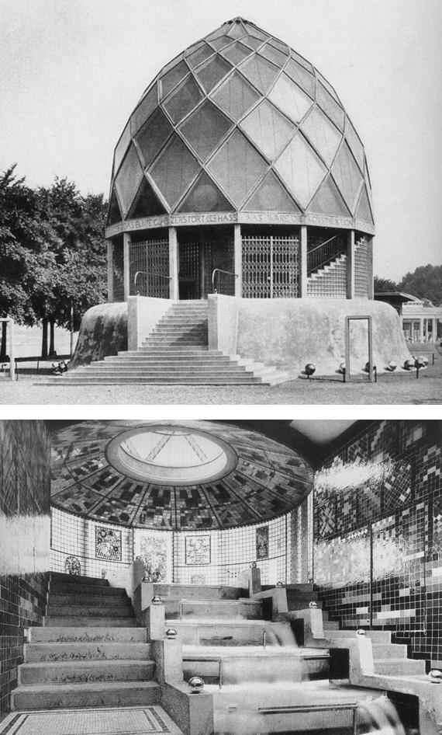
Fig. 4: Bruno Taut, Glass Pavilion, Cologne 1914
Source: Frederic J. Schwarz, The Werkbund: Design Theory and Mass Culture before the First World War. New Haven and London, 1996, pp. 184-85.
Image rights may be held by: VG Kunst-Bild
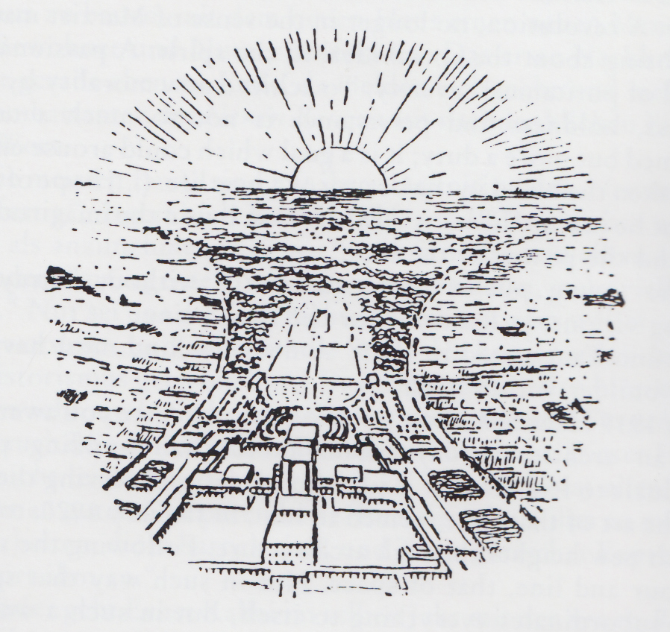
Fig. 5: Bruno Taut, Illustration from ’Die Stadtkrone’, Jena 1919. Bird’s-eye view
Sharp, D. (1966) Modern Architecture and Expressionism, London and New York: Longmans, 96.
Image rights may be held by: VG Kunst-Bild

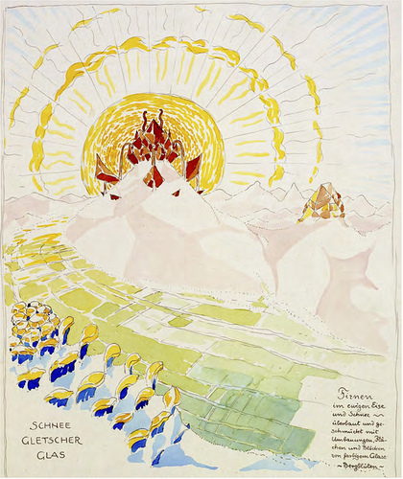
Fig. 6: Bruno Taut, Illustration from Alpine Architecture, 1919
Pehnt, W. (1985) Expressionist Architecture in Drawings, Van Nostrand Reinhold: New York, Melbourne and Agincourt.
Image rights may be held by: VG Kunst-Bild

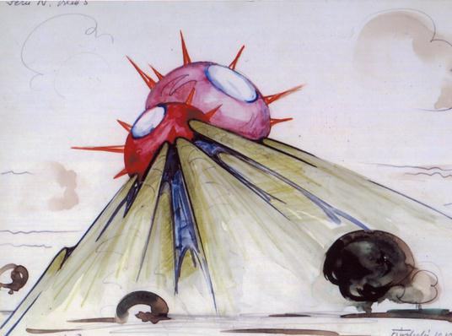
Fig. 7: Hermann Finsterlin, Concert Hall (IV-5), 1919, Watercolour
http://www.baunetz.de/img/44250227_c2e1636267.jpg
Image rights may be held by: VG Kunst-Bild

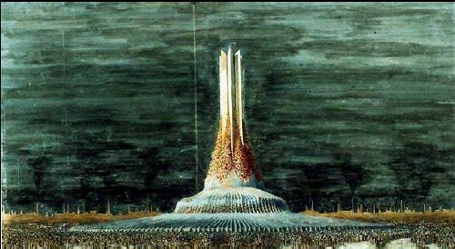
Fig. 8: Wassili Luckhardt, Religious building, c. 1920, First version
http://www.studyblue.com/notes/note/n/revision-slides/deck/884603
Image rights may be held by: VG Kunst-Bild

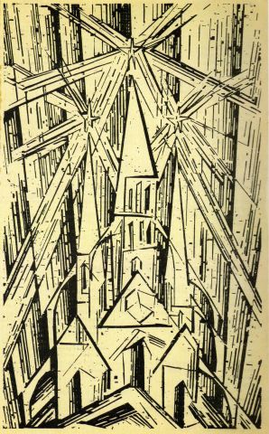
Fig. 9: Lyonel Feininger, Cathedral, Cover for the Manifesto and Programme of the Staatliche Bauhause, April 1919
Zinkätzung nach einem Holzschnitt auf graugrünem Werkdruckpapier; Doppelblatt beidseitig bedruckt, Buchdruck, 30,5 x18,7 cm Bauhaus-Archiv / Museum für Gestaltung, Berlin (6806)
© Bauhaus-Archiv / Museum für Gestaltung, Berlin / VG Bild-Kunst, Bonn 2012 Photo: Markus Hawlik

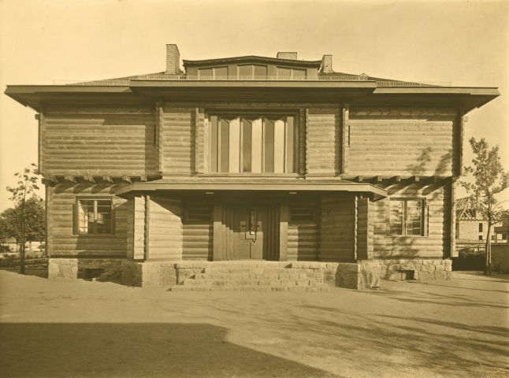
Fig. 10: Walter Gropius and Adolf Meyer, Haus Sommerfeld, Berlin, Eingangsseite, 1920-1922
Fotografie, 23,7 x 17,2 cm Bauhaus-Archiv / Museum of Design, Berlin (6155/2)
© Bauhaus-Archiv / Museum of Design, Berlin / VG Bild-Kunst, Bonn 2012

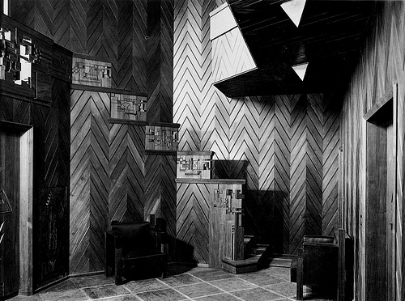
Fig. 11: Walter Gropius and Adolf Meyer, Sommerfeld log-house, Berlin-Lichterfelde, 1920-21.
Image rights may be held by: VG Kunst-Bild
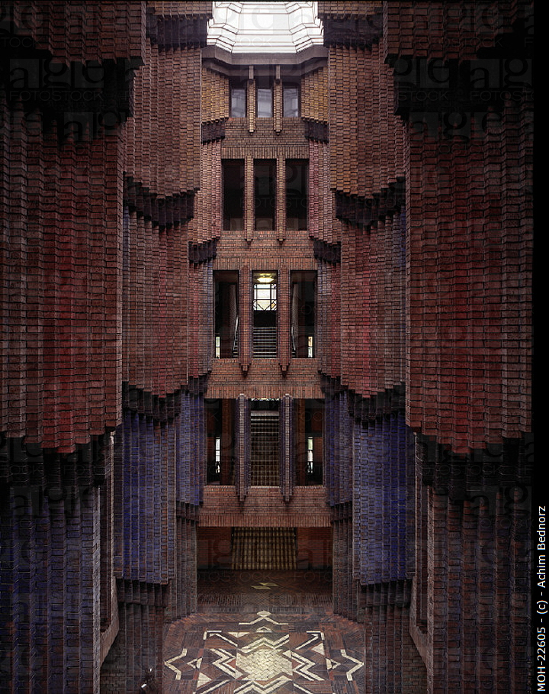
Fig. 12: Peter Behrens, Frankfurt-Hoechst, Hoechst AG/Verwaltungsgebäude Treppenhaus. Photograph: Achim Bednorz (MOH-22605)
Image Rights @ http://www.agefotostock.com/en/Stock-Images/Rights-Managed/MOH-22605

